HttpResponse

HttpResponse is a inbuilt class in django. This class exists in django.http module.
View generate the output/response using HttpResponse class.
The HttpResponse class in Django is a fundamental component of the request/response cycle, where every view function is responsible for instantiating, populating, and returning an HttpResponse object. It is used to send raw content, such as plain text, HTML, or even files, back to the client's browser.

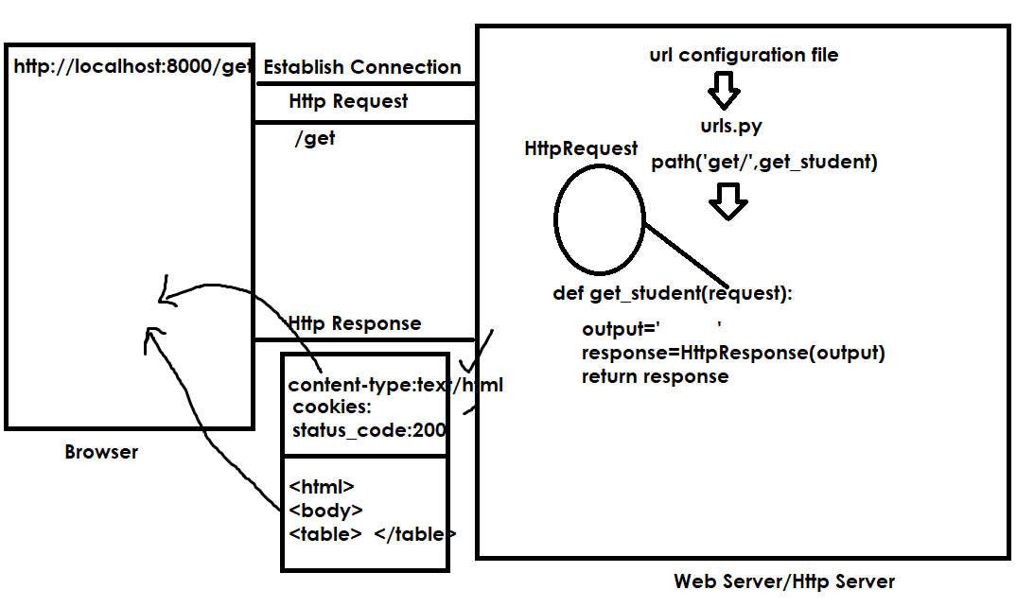

Browser always executes response based on response content-type.
This content-type also called MIME type.
MIME stands Multipurpose Internet Mail Extension
It is divided into 2 parts
- Type
- Subtype

Example:
text/plain, text/html, text/css, text/javascript
Image/jpg,image/gif,
application/pdf, application/json, application/xml

Default content type HttpResponse is text/html
This content type can be changed using keyword argument called conent_type

Syntax: HttpResponse(data,content_type=”type/subtype”)

PS C:\Users\Satish Gupta> cd D:\Backup\Django9amMar
PS D:\Backup\Django9amMar> django-admin startproject project3
PS D:\Backup\Django9amMar> cd project3
PS D:\Backup\Django9amMar\project3> python manage.py startapp app1
PS D:\Backup\Django9amMar\project3>

Views.py
from django.shortcuts import render
from django.http import HttpResponse
# Create your views here.
def get_student(request):
stud={'rollno':1,
'name':'naresh',
'course':'python'}
output=f'''
<html>
<body>
<table border=2>
<tr>
<td>Rollno</td>
<td>StudentName</td>
<td>StudentCourse</td>
</tr>
<tr>
<td>{stud['rollno']}</td>
<td>{stud['name']}</td>
<td>{stud['course']}</td>
</tr>
</table></body></html>'''
response=HttpResponse(output,content_type="text/html")
return response

def get_student1(request):
stud={'rollno':1,
'name':'naresh',
'course':'python'}
output=f'''
<html>
<body>
<table border=2>
<tr>
<td>Rollno</td>
<td>StudentName</td>
<td>StudentCourse</td>
</tr>
<tr>
<td>{stud['rollno']}</td>
<td>{stud['name']}</td>
<td>{stud['course']}</td>
</tr>
</table></body></html>'''
response=HttpResponse(output,content_type="text/plain")
return response

urls.py
from django.contrib import admin
from django.urls import path
from app1.views import get_student,get_student1
urlpatterns = [
path('admin/', admin.site.urls),
path('get/',get_student),
path('get1/',get_student1)
]

Settings.py
INSTALLED_APPS = [
'django.contrib.admin',
'django.contrib.auth',
'django.contrib.contenttypes',
'django.contrib.sessions',
'django.contrib.messages',
'django.contrib.staticfiles',
'app1',
]

Template

What is template?
Template is file (HTML file) but it can any file.
Template is an HTML file.
Template is a dynamic HTML file.
Template is collection HTML tags, css, javascript and template tags.
Template allows to separate business logic and presentation logic.
In application development template is used for building presentation logic.

Basic steps for working with templates
- Create templates folder
  - Project container folder
  - Application folder
- Create template (html)
- Include template within view (rendering process)
- Template path (settings.py)

